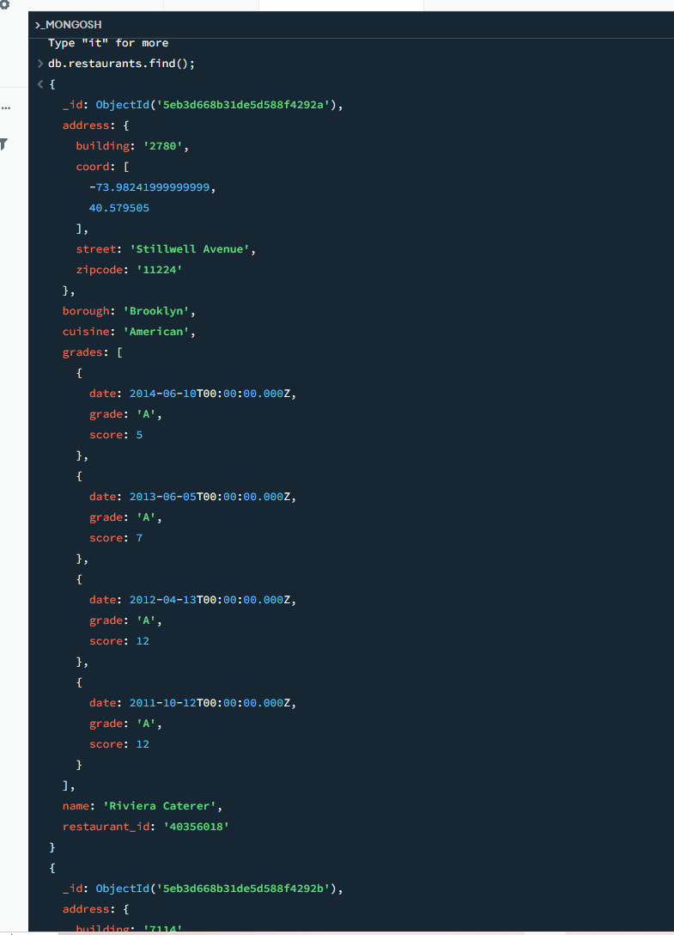
Q1: db.restaurants.find();
Q2: db.restaurants.find({},{ "restaurant_id": 1, "name": 1, "borough": 1, "cuisine": 1 })
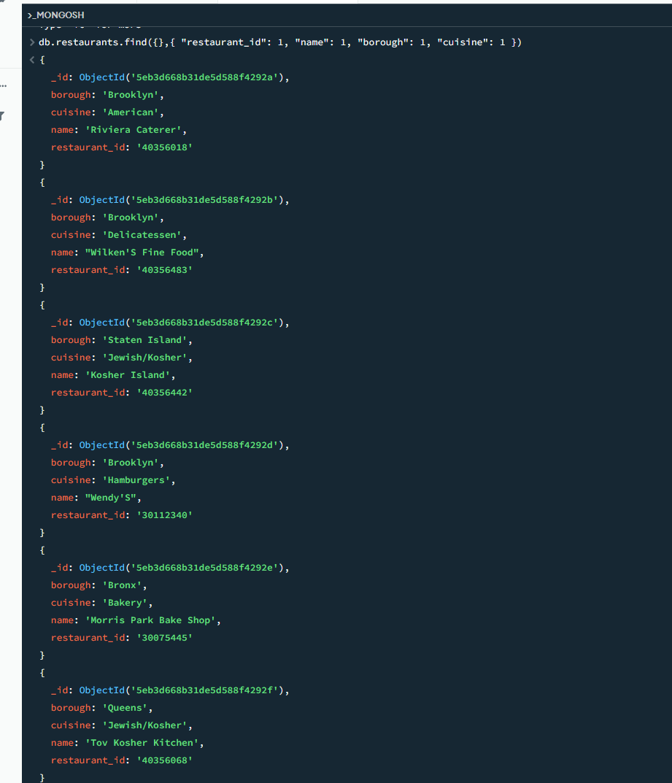

Q3: db.restaurants.find({},{ "restaurant_id": 1, "name": 1, "borough": 1, "cuisine": 1, "_id": 0 })
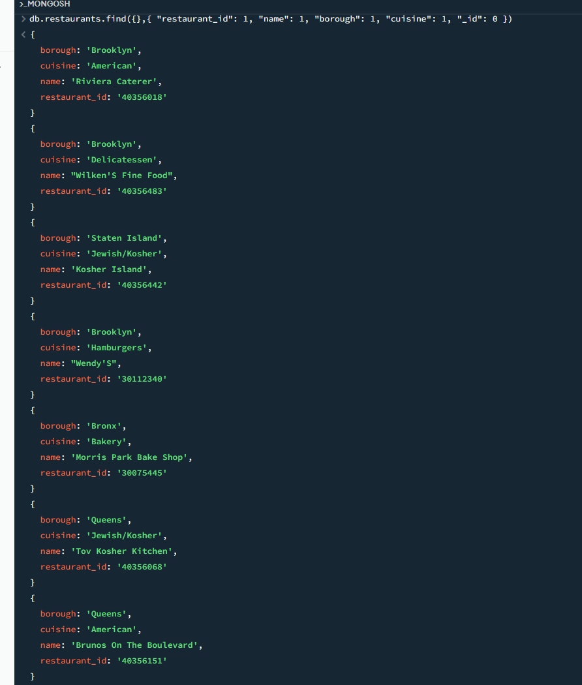

Q4:
db.restaurants.find({"address.coord": { $lt: -95.754168 }})
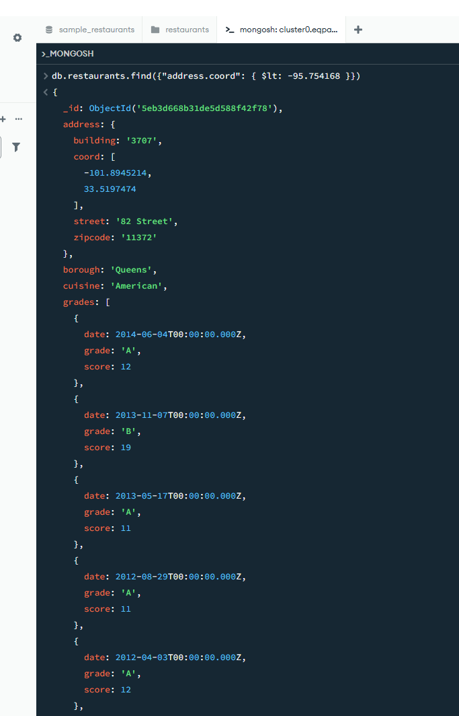
Q5:
db.restaurants.find({$and: [{ "cuisine": { $ne: "American " } },{ "grades.score": { $gt: 70 } },{ "address.coord": { $lt: -65.754168 } }]})

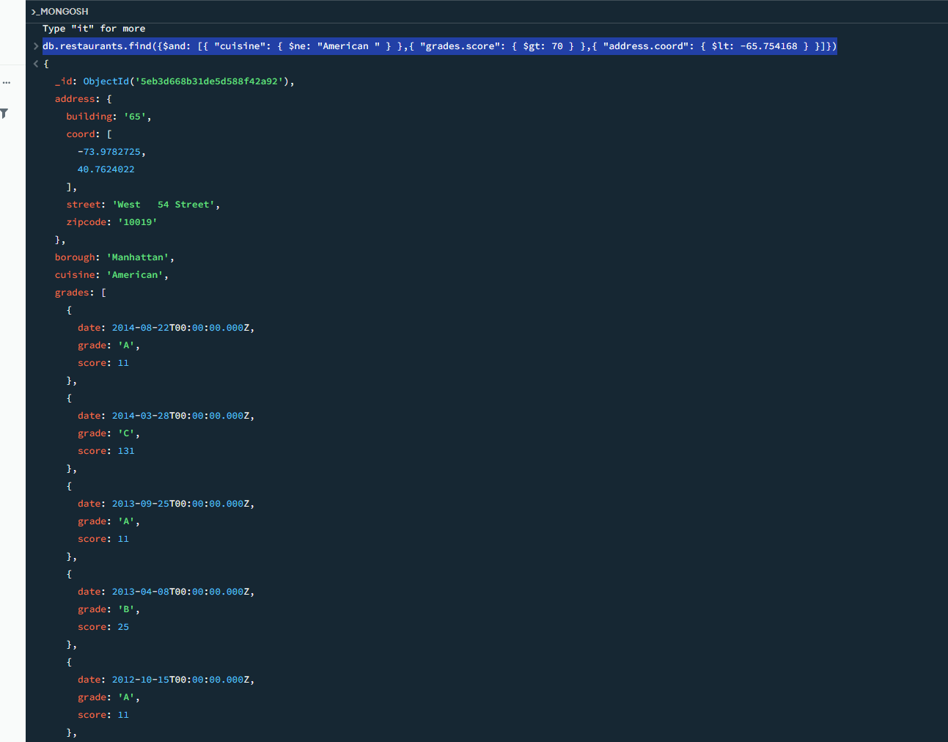

Q6:
db.restaurants.find({cuisine: { $ne: "American " },"grades.score": { $gt: 70 },"address.coord": { $lt: -65.754168 }})

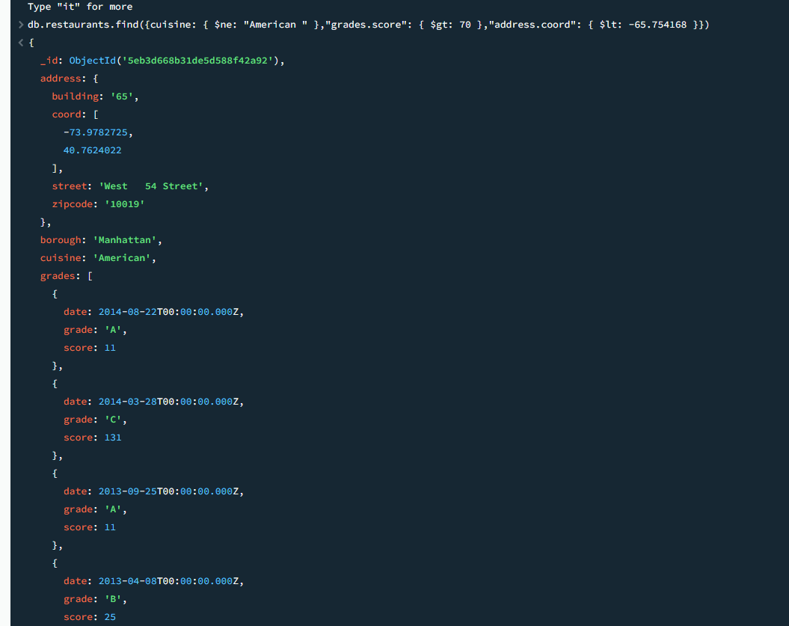

Q7:

db.restaurants.find(
{ cuisine: { $ne: "American " }, "grades.grade": "A", borough: { $ne: "Brooklyn" }},
{ restaurant_id: 1, name: 1, borough: 1, cuisine: 1, _id: 0 } ).sort({ cuisine: -1 })

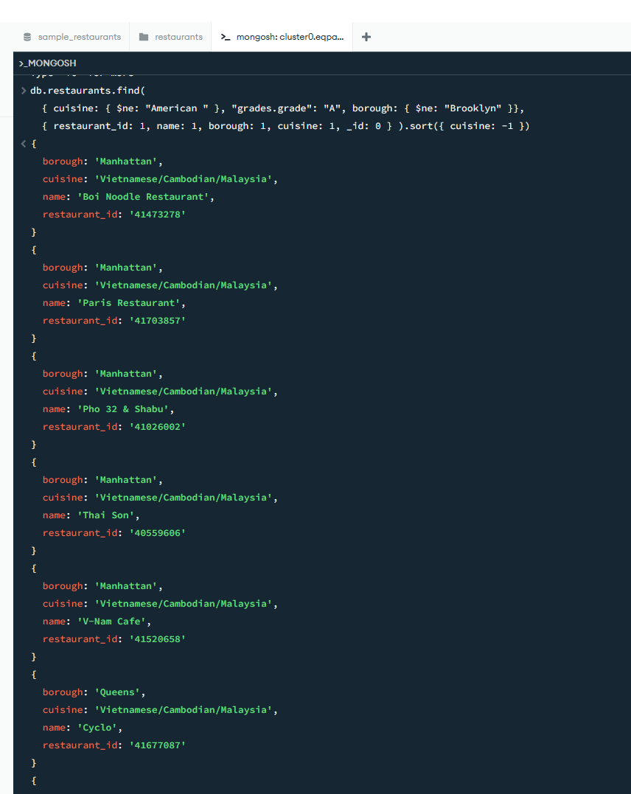
Q8:
db.restaurants.find(
{ name: /^Wil/ }, { restaurant_id: 1, name: 1, borough: 1, cuisine: 1 }
)

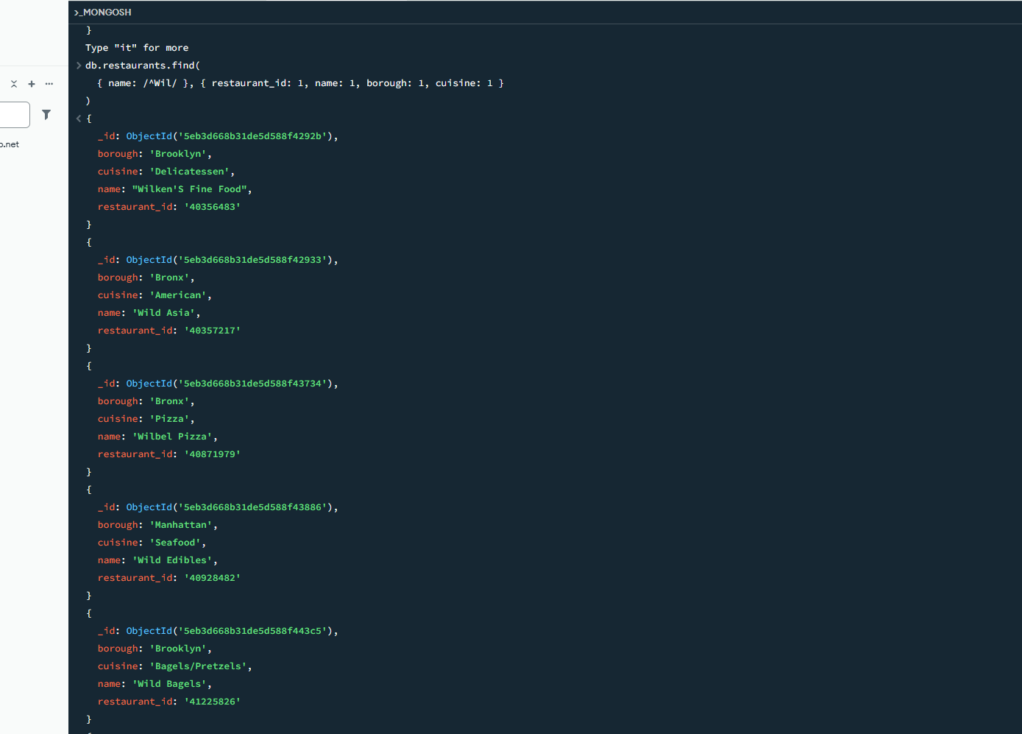

Q9
db.restaurants.find( { name: /ces$/ },
{ restaurant_id: 1, name: 1, borough: 1, cuisine: 1 }
)

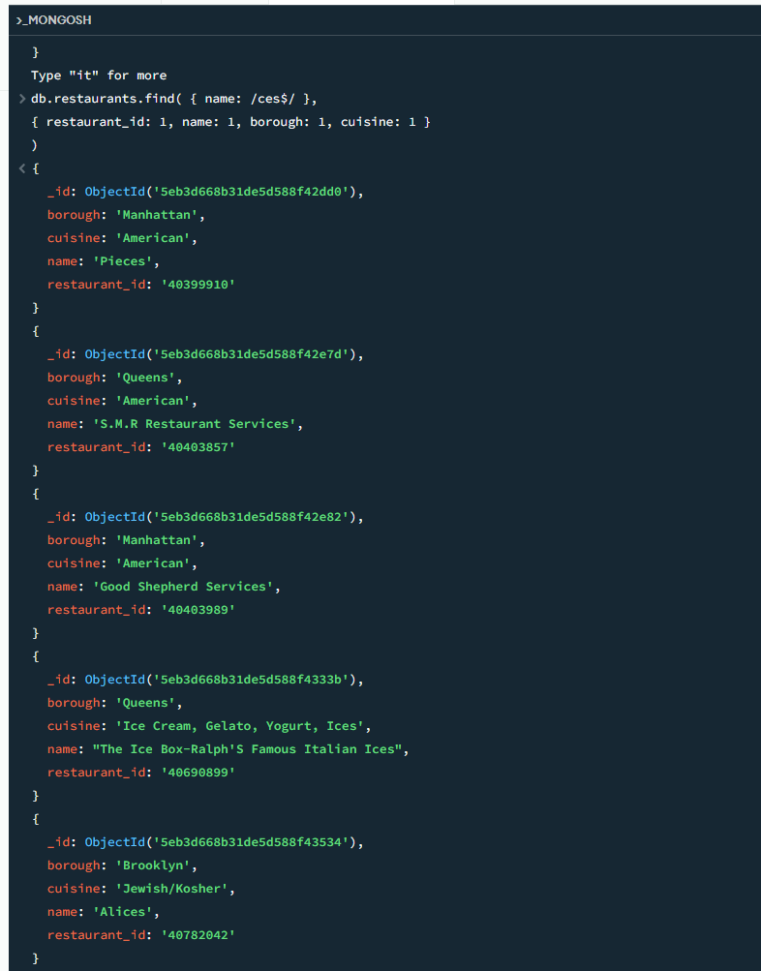

Q10

db.restaurants.find(
{ name: /Reg/ },
{ restaurant_id: 1, name: 1, borough: 1, cuisine: 1 }
)

